A Project Report

ON

DURABLE FURNITURES

BY

SIHLELO D DLAMINI

MARSELINA T MATSE

BANDISA L DLAMINI

LINDELANI N NDLANGAMANDLA

**Acknowledgements**

We would like to express our heartfelt gratitude to the Advanced School of ICT (ASIT) and Mr. T Zwane for giving us the opportunity to work under their guidance. Our sincere thanks to Mr. Zweli who guided us and paved the way for us as we completed our project.

The Successful completion of our project would not have been possible without the dedicated support from all our mentors, family, friends and God.

Sihlelo Dlamni

Marselina Matse

Bandisa Dlamini

Lindelani Ndlangamandla

**Abstract**

**Problem statement**

DURABLE FURNITURES is selling various types of Furniture’s. The company advertises by distributing the pamphlets, advertising on television and so on. Due to rapid development in internet field, the company decides to launch a website where people will get all the information about the various products available with them easily.

**Problem Solution**

The website is to be developed for the Windows Platform using HTML5, JavaScript and Geolocation. The site should work well in all leading browsers including Chrome, IE, Firefox etc.

Chapter – 1

**Requirements**

* Monitor/Screen
* Mouse
* Keyboard
* Web Browser
  1. **Project Definition**

DURABLE FURNITURES

* Furniture Website
  1. **Project introduction**

This is a website where people will get all the information about the various products available with Durable Furnitures easily and makes it easier for durable furnitures to advertise their products in a more modern and effective way.

Durable Furnitures website was built using HTML5, CSS, JavaScript and Angular JS.

Project Goals

Goals for this website where to:

1. Give easier access to our products
2. To allow use to keep in touch with durable furnitures
3. To advertise different furniture brands found in the store
   1. **Previous Problem**
4. The word would not reach out to most customers.
   1. Features
5. Simple and clear design
6. Responsive
7. Fast to load
8. Accurate information

**1.5 Summary**

Durable furnitures is an e-commerce website which helps to choose a wide range of products through your desktop rather than visiting the outlets. It is developed using HTML5, CSS, JavaScript and Angular. It is been developed to handle accurate stock and also to overcome a payment gateway problem.

**Admins:**

Admins can add and edit the products and product details.

**Customers:**

The customer can view the application without registration and view any of our products. After the product is selected customer needs to provide some additional details like shipping address, name, account details, phone number and email address after that the payment will be initiated by the customer, after successful payment the customers will get an alert confirming the purchase

Chapter - 2

**2.1 Analysis**

The Durable furnitures home page has a suitable logo with the logo there is a search bar which will filter out our best seller items which consist of the number sales price and product name. The theme of the website is black and white to match the color of the sponsor brands and the orange to match the color of one of the sponsor brands. The homepage also consists of some basic items from each of the brands displayed in two columns to make the user compare their favorite brand design, below that section is our footer which consists of our social links, brand links and website main and frequently asked question (FAQ) links.

In the shop page there is a header without the search bar from the home page but instead there are navigation buttons for each of our brands which when clicked n it will filter out the other brands and show you your desired brand.

When the user clicks on a desired product it will then take you to a page where there will be a full image of the product the product name and product price followed by a download button which downloads the product details. Below the above comes a recommended for you section where the user can compare the product with other products, and after this section comes the small details of the product.

The about us page gives you information about DURABLE FURNITURES and our goal as a furniture business we also give information about what makes us different from all our competing brands

In our contact us page, you will find a form which will allow you to send a message to Durable furnitures if you want to send a direct email to us you can click on the email next to the form and underneath the form there is a map to help see where we are located.

There is also the Frequently Asked Questions page where the user will find questions that previous customers have asked us.

Chapter – 3

3.1 Data Flow Diagram

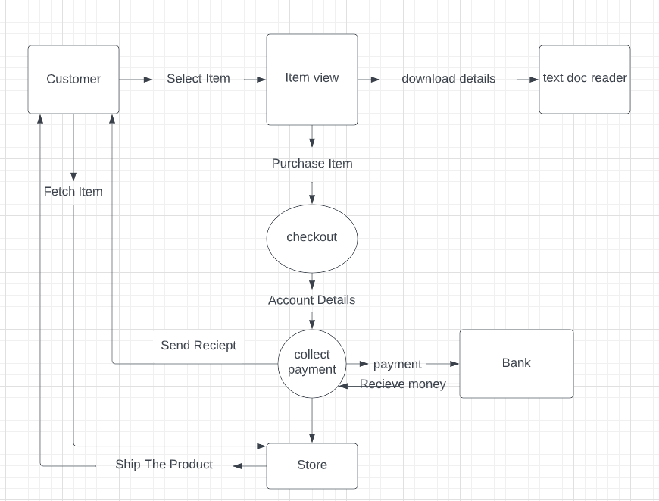

3.2 Flow Chart/ Process Diagram

For a purchase

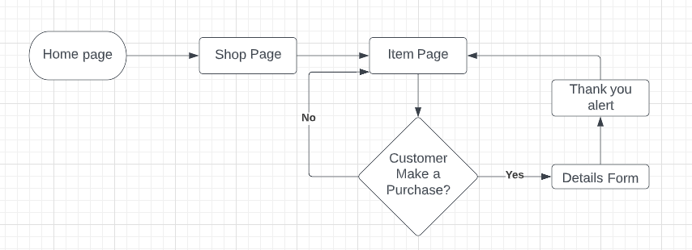

Contact Durable Furniture

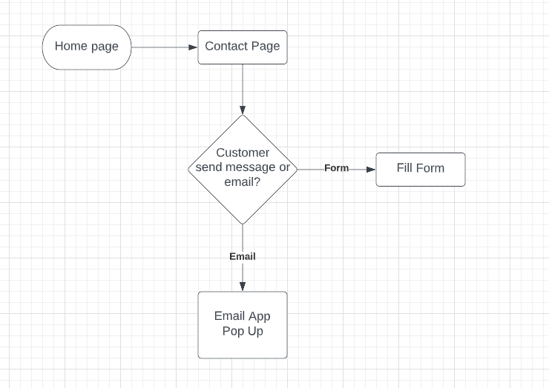

Chapter – 4

Screen Shots

These screen shots will be taken using chrome web browser

4.1 Home page

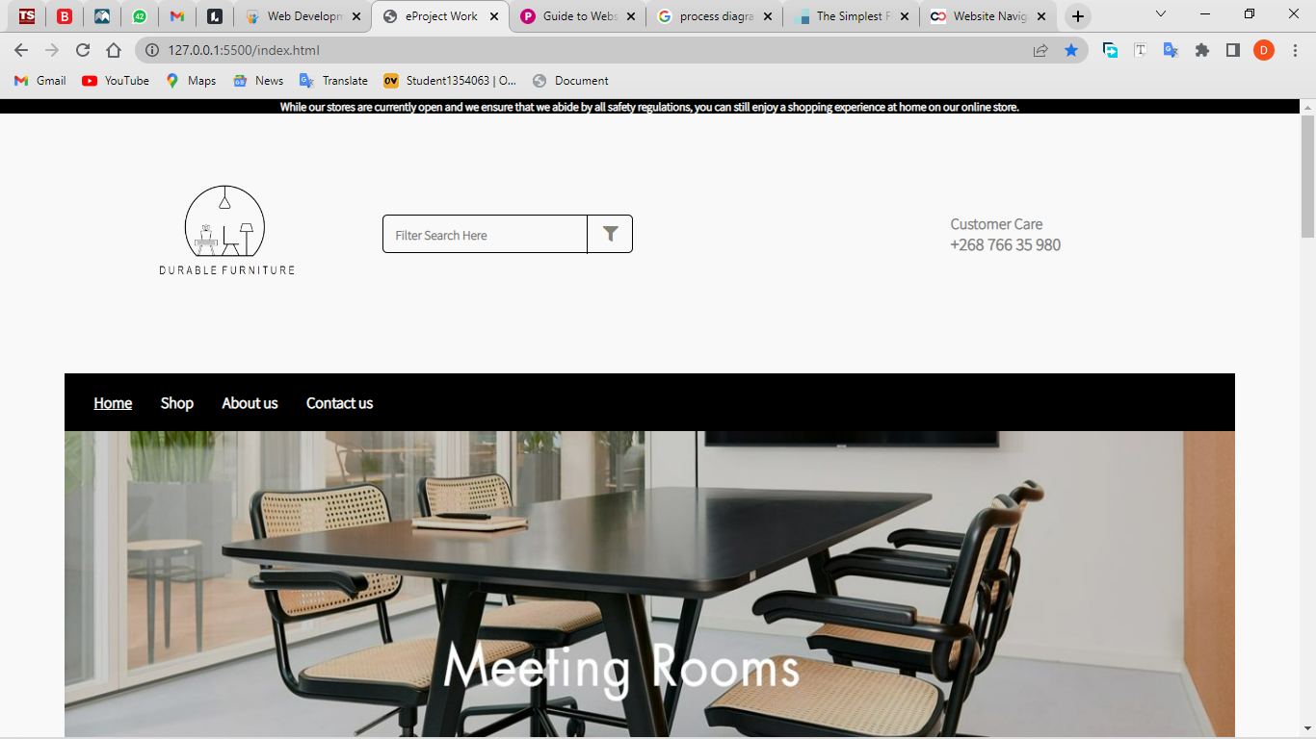

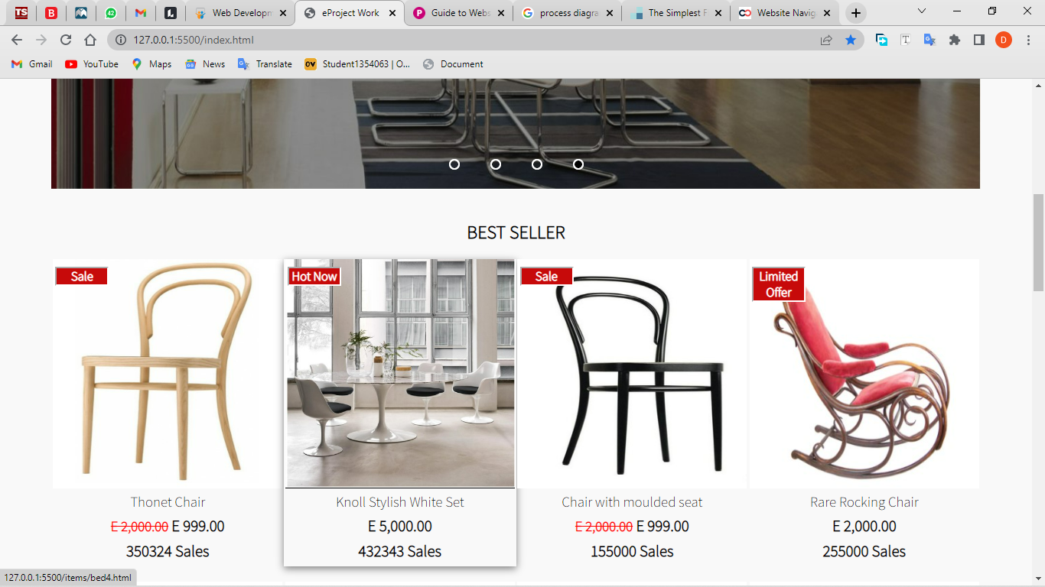

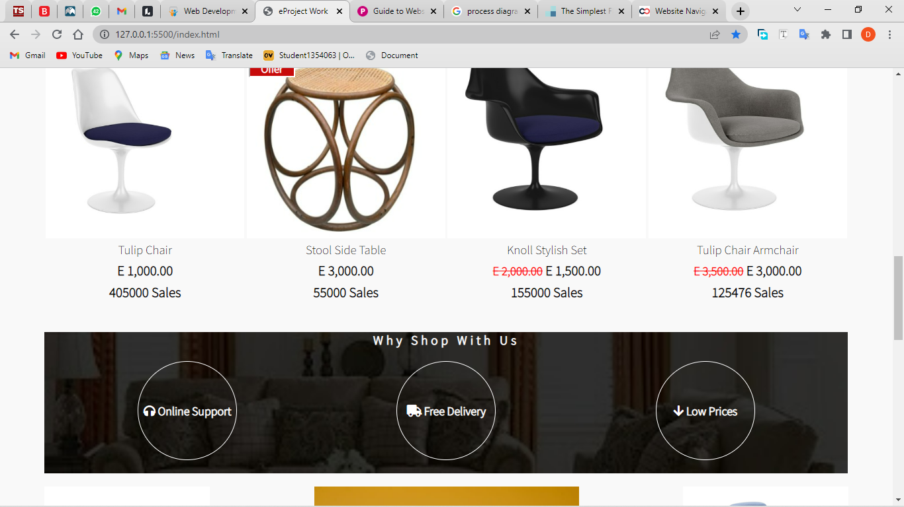

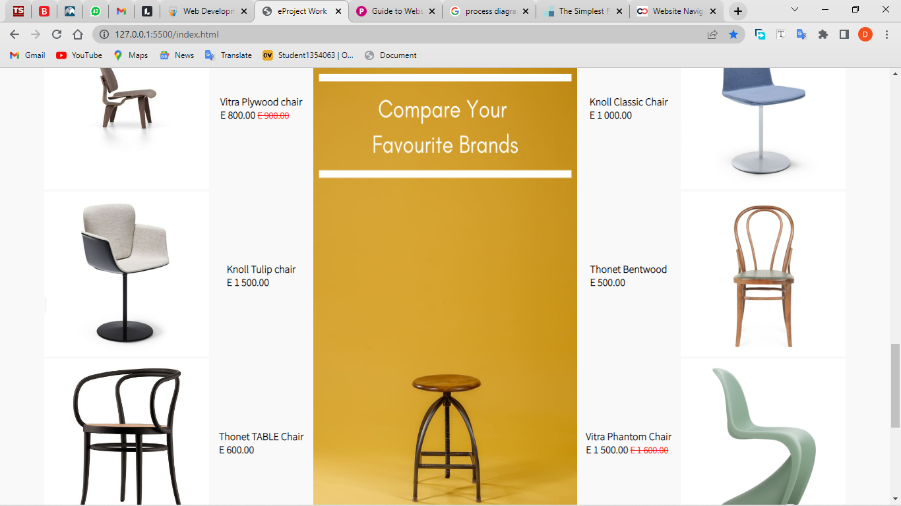

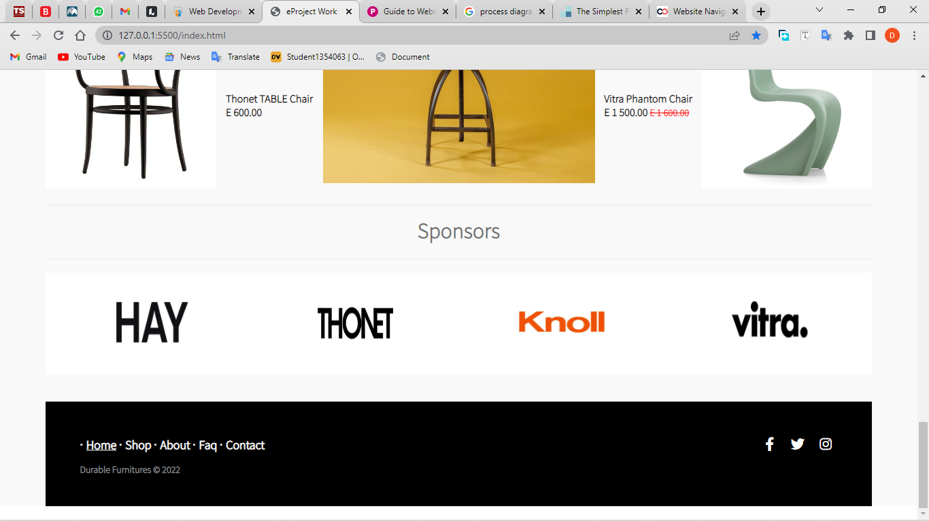

* 1. Shop Page

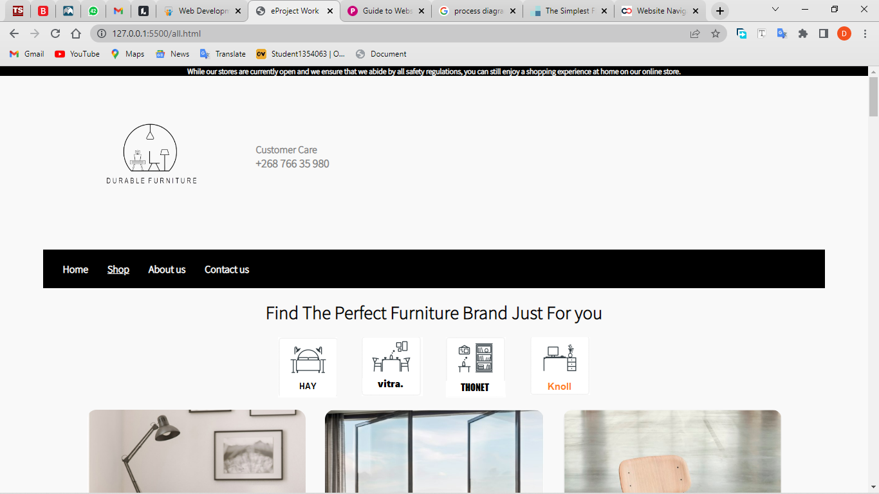

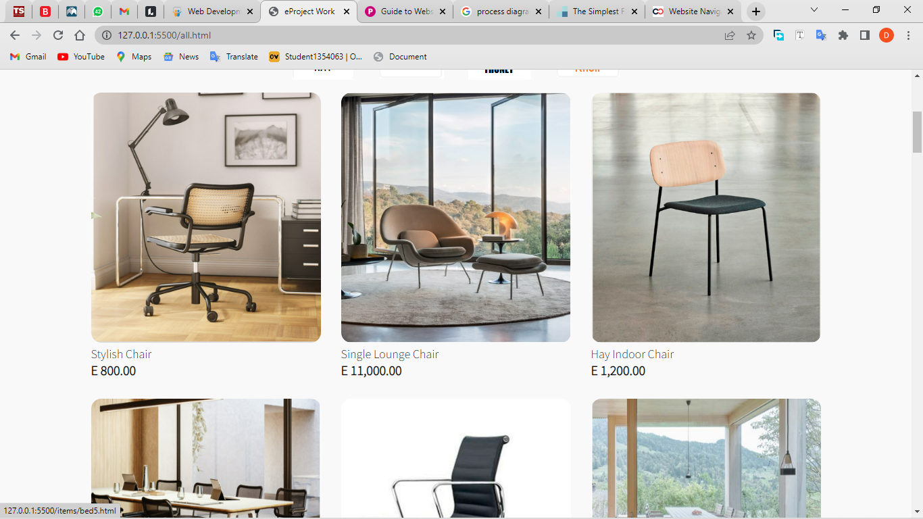

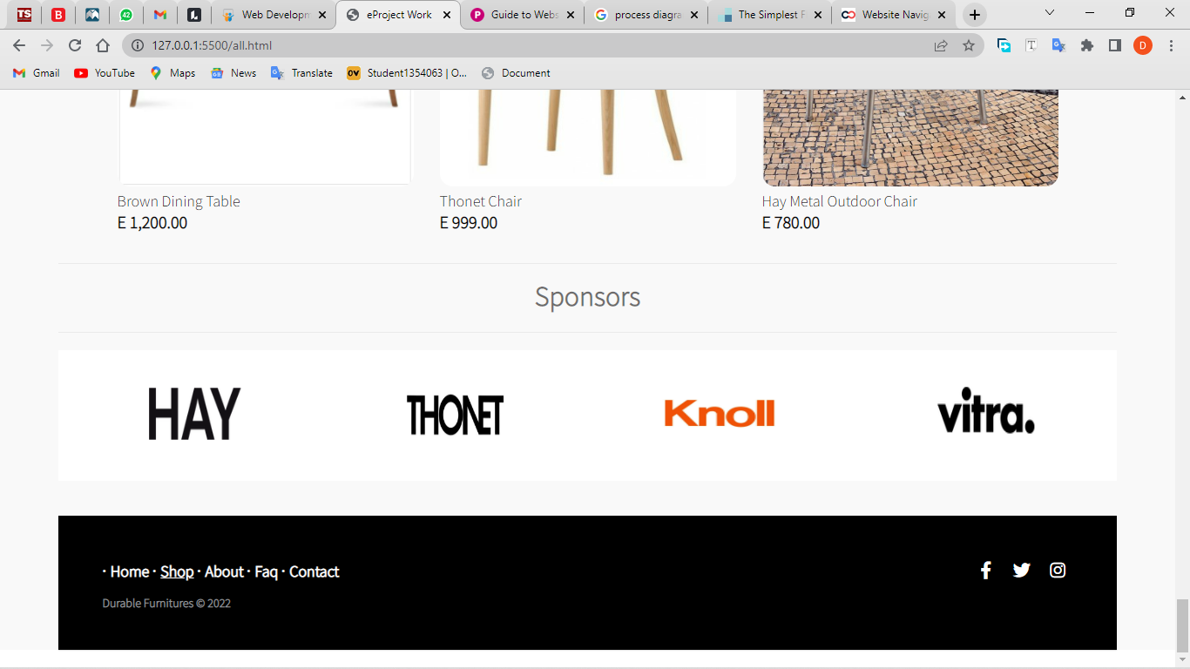

4.3 About Page

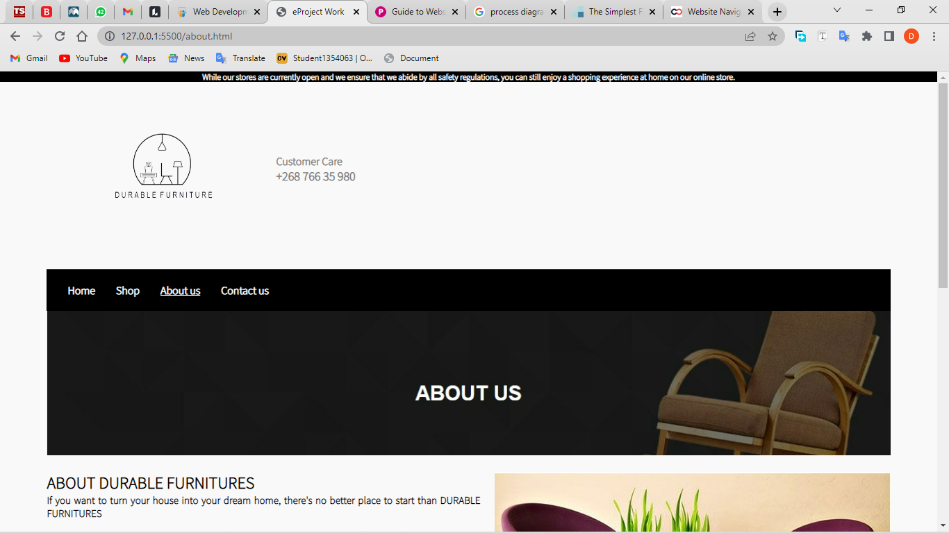

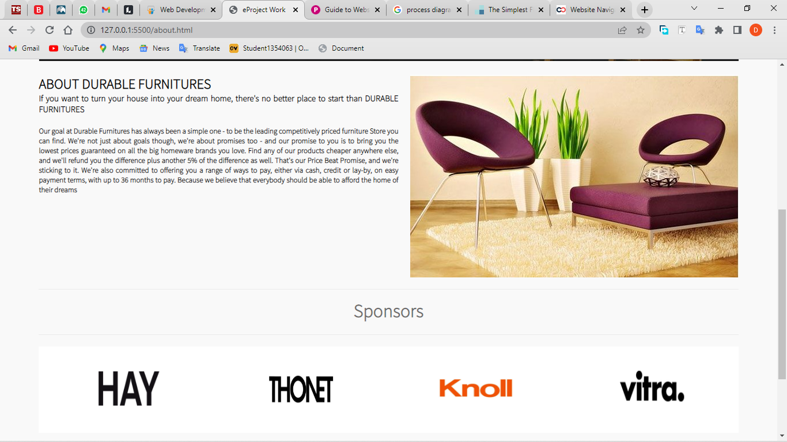

* 1. Contact Us Page

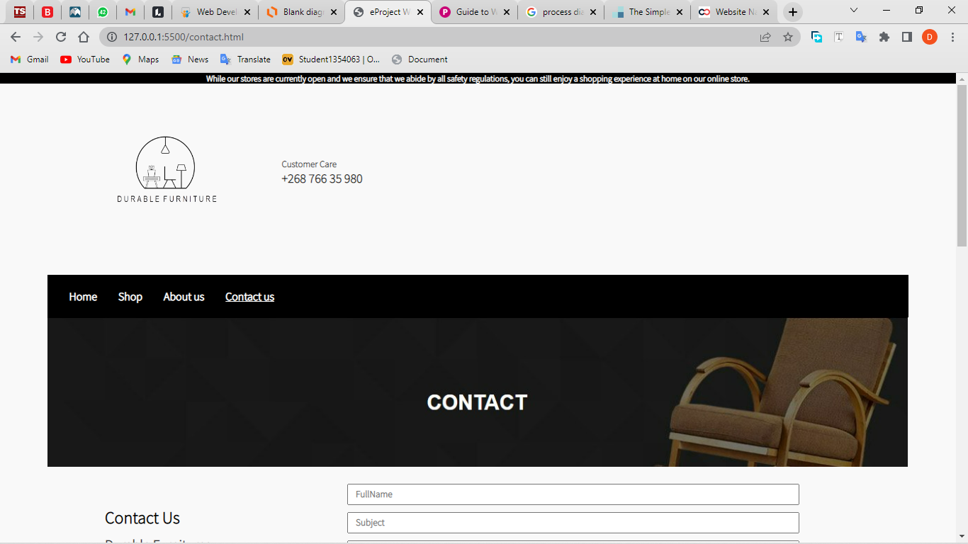

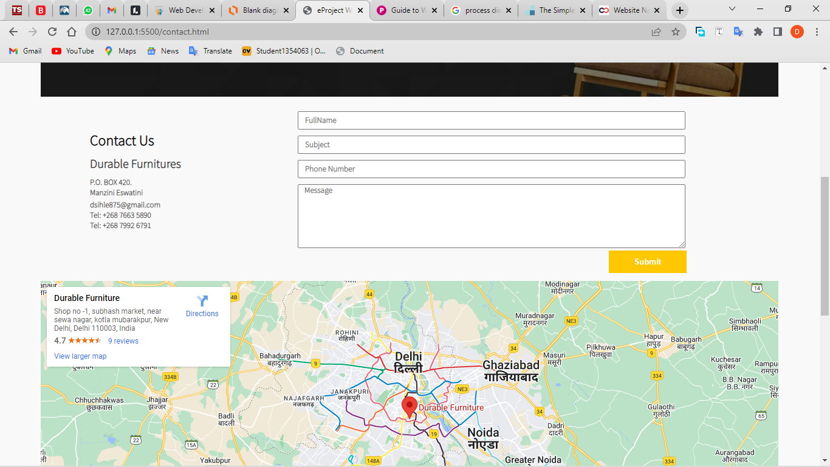

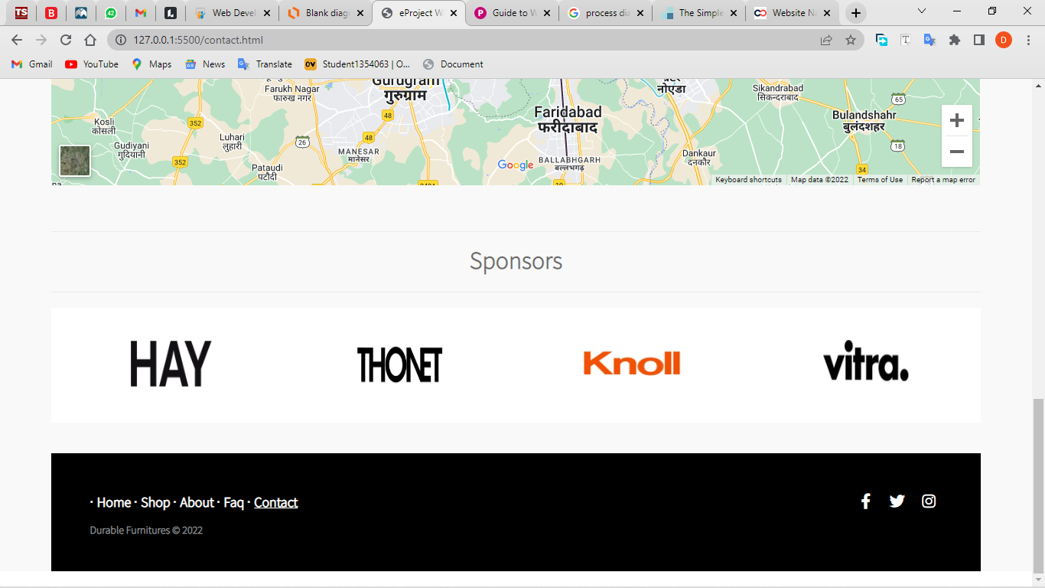

* 1. FAQ page

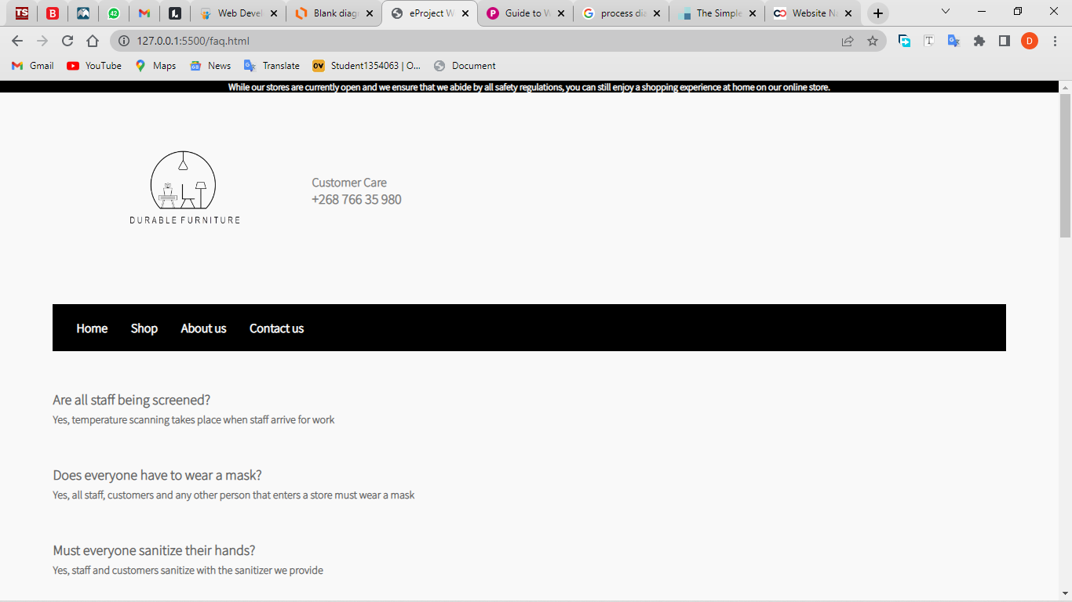

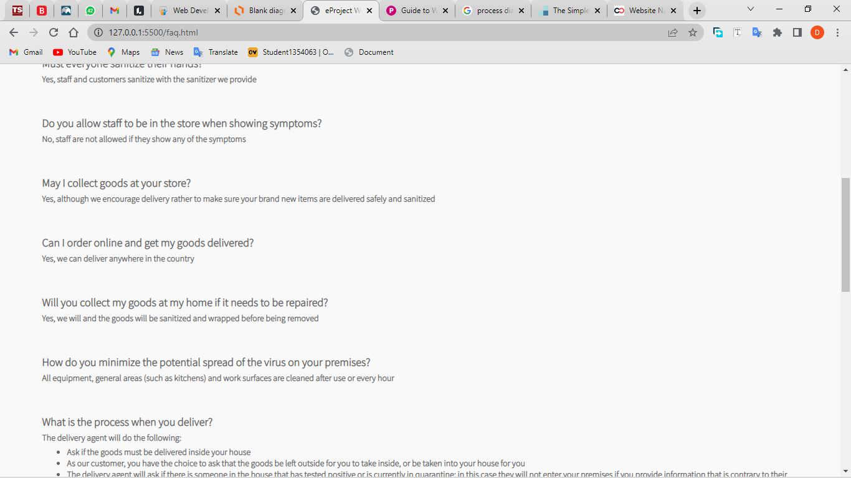

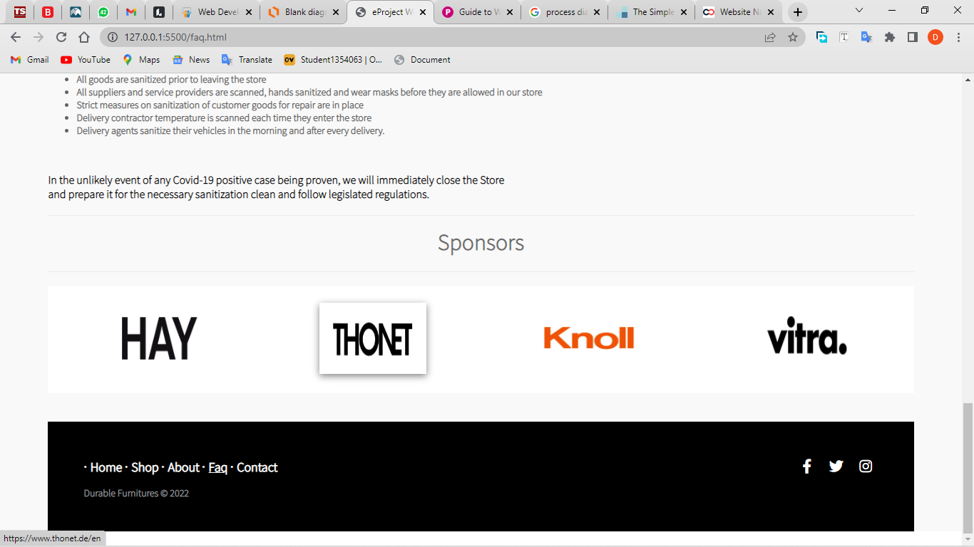

* 1. Item Page

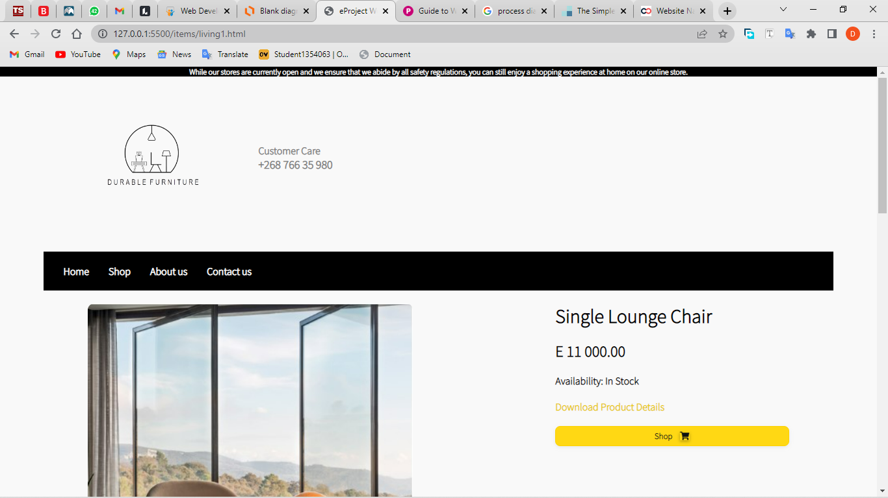

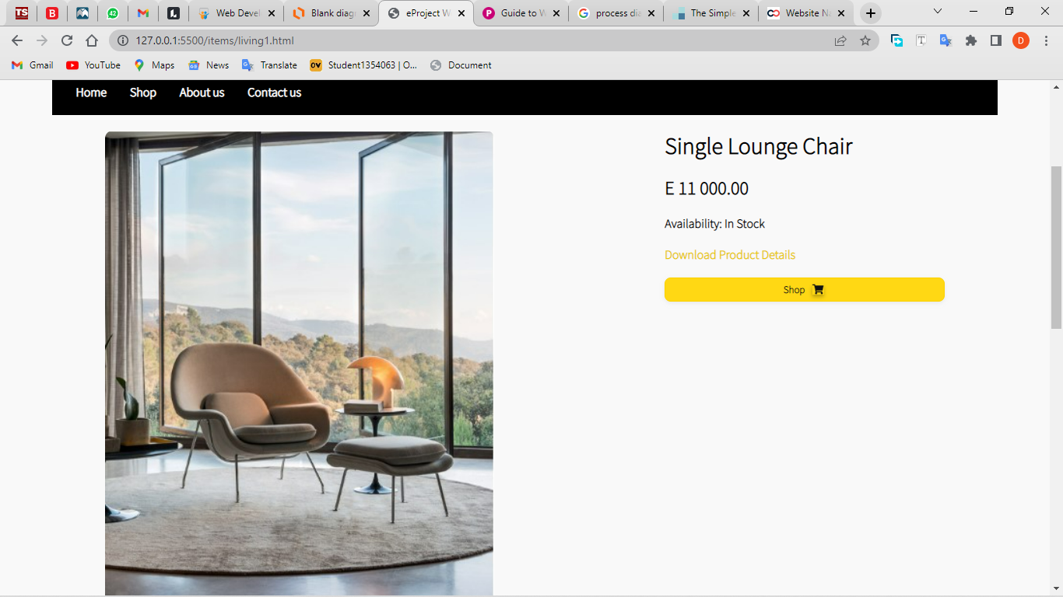

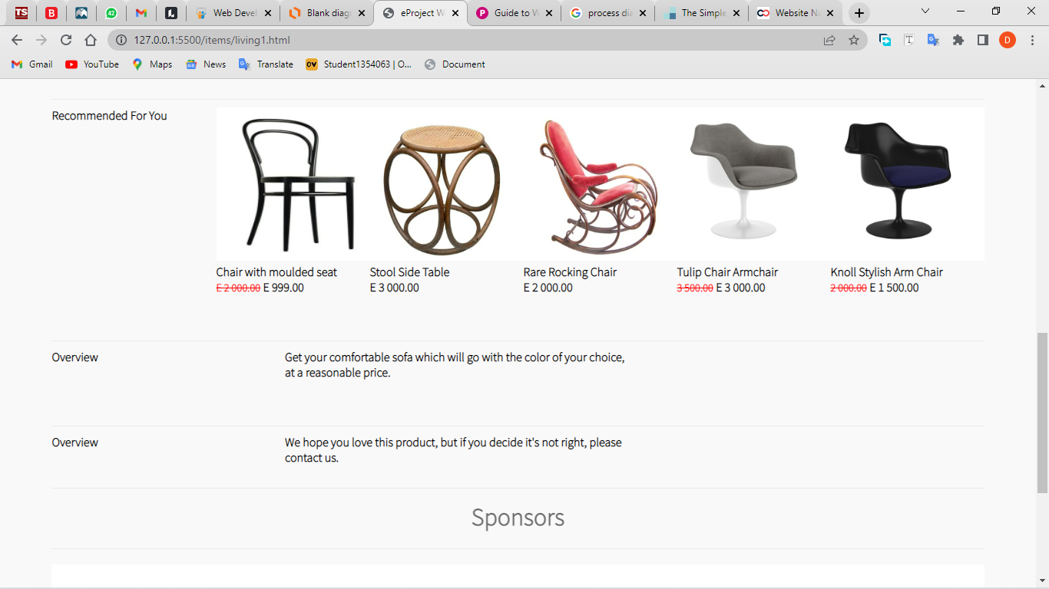

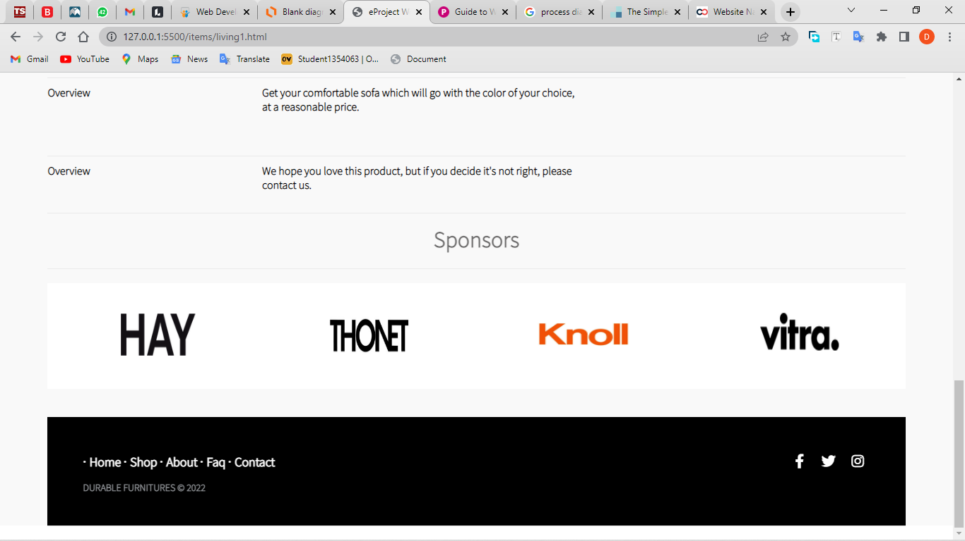

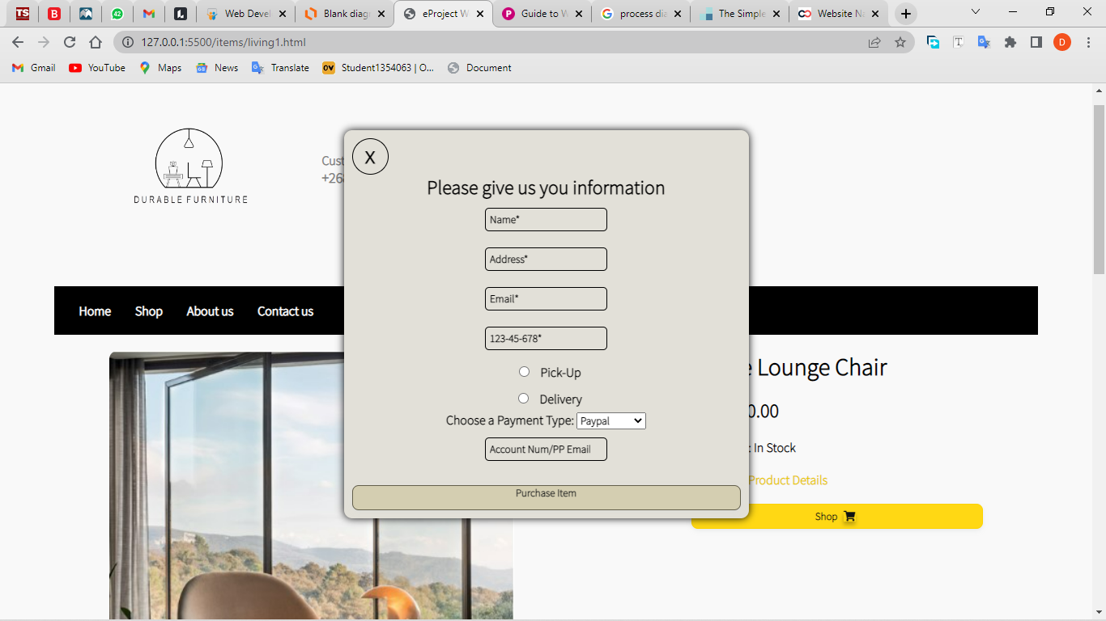

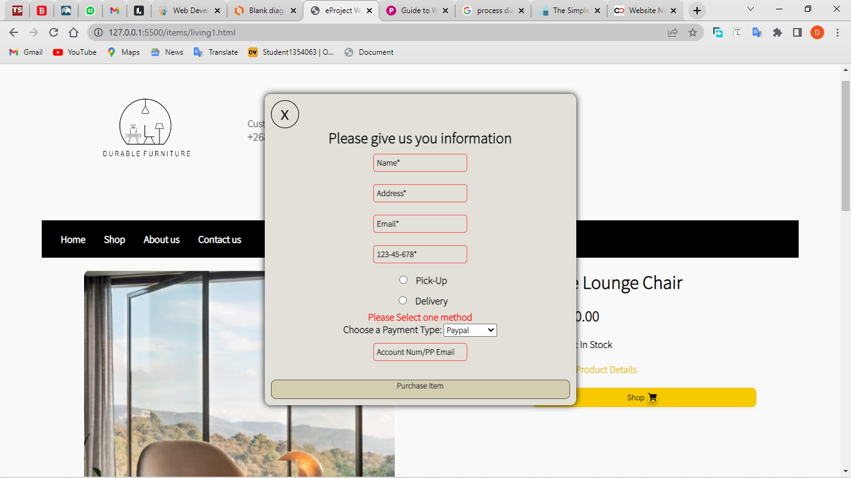

**Chapter – 5**

**5.1 HTML FILES**

**Home page (index.html)**

<!DOCTYPE html>

<!-- app module link -->

<html lang="en" ng-app="myApp">

<head>

    <meta charset="UTF-8">

    <meta http-equiv="X-UA-Compatible" content="IE=edge">

    <meta name="viewport" content="width=device-width, initial-scale=1.0">

    <!-- fontawesome link -->

    <script src="https://kit.fontawesome.com/3cc2740288.js" crossorigin="anonymous"></script>

    <!-- angular.min.js link -->

    <script src="./app/lib/angular.min.js"></script>

    <!-- main style -->

    <link rel="stylesheet" href="./styles/style.css">

    <title>eProject Work</title>

</head>

<!-- angular controller linked here -->

<body ng-controller="myController">

    <div class="container">

        <p class="h-text">

            While our stores are currently open and we ensure that

            we abide by all safety regulations, you can still

            enjoy a shopping experience at home on our online

            store.

        </p>

        <header>

                <div class="h-div">

                    <!-- Logo -->

                    <img src="./images/logo/logo2.png" alt="logo" class="logo">

                    <div class="search-bar">

                        <!-- angular filter search linked with variable search -->

                        <input type="text" ng-model="search" id="search" placeholder="Filter Search Here">

                        <i class="fa fa-filter" style='color:#838277'></i>

                    </div>

                    <div class="numbers">

                        <p>Customer Care</p>

                        <p class="t1">+268 766 35 980</p>

                    </div>

                </div>

        </header>

        <br>

        <nav>

            <ul class="ul">

                <!-- header navigation links -->

                <li class="li"><a href="#" class="a" style="text-decoration: underline;">Home</a></li>

                <li class="li"><a href="./all.html" class="a">Shop</a> </li>

                <li class="li"><a href="./about.html" class="a">About us</a></li>

                <li class="li"><a href="./contact.html" class="a">Contact us</a></li>

            </ul>

        </nav>

        <main>

            <div class="m-div">

                <!-- image slider start -->

                <div class="slider">

                    <div class="slides">

                        <!-- radio buttons to show the image slider position -->

                        <input type="radio" name="radio-btn" id="radio1">

                        <input type="radio" name="radio-btn" id="radio2">

                        <input type="radio" name="radio-btn" id="radio3">

                        <input type="radio" name="radio-btn" id="radio4">

                        <!-- banner images -->

                        <div class="slide first">

                            <img src="./images/Banner/banner1.jpg" alt="banner">

                        </div>

                        <div class="slide">

                            <img src="./images/Banner/banner2.jpg" alt="banner">

                        </div>

                        <div class="slide">

                            <img src="./images/Banner/banner3.jpg" alt="banner">

                        </div>

                        <div class="slide">

                            <img src="./images/Banner/banner4.jpg" alt="banner">

                        </div>

                        <!-- radio buttons to show the image slider position automatically-->

                        <div class="navigation-auto">

                            <div class="auto-btn1"></div>

                            <div class="auto-btn2"></div>

                            <div class="auto-btn3"></div>

                            <div class="auto-btn4"></div>

                        </div>

                    </div>

                        <!-- radio buttons to show the image slider position manually -->

                    <div class="navigation-manual">

                        <label for="radio1" class="manual-btn"></label>

                        <label for="radio2" class="manual-btn"></label>

                        <label for="radio3" class="manual-btn"></label>

                        <label for="radio4" class="manual-btn"></labe>

                    </div>

                </div>

                <br><br>

                <div class="item-1">

                    <h3 style="text-align:center;">BEST SELLER</h3>

                    <br>

                    <ul>

                        <!-- angular directive ng-repeat used to display image and filter search to filter out the searched items -->

                        <li ng-repeat="item in items | filter: search" class="li-item">

                            <!--for linking to items page-->

                            <a href="{{item.link}}">

                                <!-- image link from app.js -->

                                <img ng-src="{{item.thumb}}">

                                <!-- name of product from app.js -->

                                <p class="name">{{item.name}}</p>

                                <!-- price of product form app.js -->

                                <p><span class="high">{{item.high | currency: 'E '}}</span> <span class="">{{item.price | currency: 'E '}}</span></p>

                                <!-- number of sales from app.js -->

                                <p>{{item.noOfSales}} Sales</p> <p class="sale-d">{{item.sale}}</p>

                            </a>

                        </li>

                    </ul>

                </div>

                <br>

                <div class="divider-par">

                    <h2>Why Shop With Us</h2>

                    <div class="divider">

                        <div>

                            <p><i class="fa fa-headphones"></i> Online Support</p>

                        </div>

                        <div>

                            <p><i class="fa fa-truck"></i> Free Delivery</p>

                        </div>

                        <div>

                            <p><i class="fa fa-arrow-down"></i> Low Prices</p>

                        </div>

                    </div>

                </div>

                <br>

                <div class="item-2">

                    <div class="item-min">

                        <div class="img-item">

                            <a href="./items/vitrap.html"><img src="./images/brands/vitra.jpg" alt="hay chair" class="item-2-img"></a>

                            <div class="item-2-text">

                                <p>Vitra Plywood chair</p>

                                <p>E 800.00 <span class="high">E 900.00</span></p>

                            </div>

                        </div>

                        <div class="img-item">

                            <a href="./items/knollt.html"><img src="./images/brands/knoll.jpg" alt="knoll chair" class="item-2-img"></a>

                            <div class="item-2-text">

                                <p>Knoll Tulip chair</p>

                                <p>E 1 500.00</p>

                            </div>

                        </div>

                        <div class="img-item">

                            <a href="./items/thonett.html"><img src="./images/brands/thonet.jpg" alt="knoll chair" class="item-2-img"></a>

                            <div class="item-2-text">

                                <p>Thonet TABLE Chair</p>

                                <p>E 600.00</p>

                            </div>

                        </div>

                    </div>

                    <div>

                        <img src="./images/brands/sa.png" alt="" class="item-2-banner">

                    </div>

                    <div class="item-min1">

                        <div class="img-item1">

                            <div class="item-2-text">

                                <p>Knoll Classic Chair</p>

                                <p>E 1 000.00</p>

                            </div>

                            <a href="./items/knollc.html"><img src="./images/brands/knoll3.jpg" alt="hay chair" class="item-2-img"></a>

                        </div>

                        <div class="img-item1">

                            <div class="item-2-text">

                                <p>Thonet Bentwood</p>

                                <p>E 500.00</p>

                            </div>

                            <a href="./items/thonetb.html"><img src="./images/brands/thonet3.jpg" alt="hay chair" class="item-2-img"></a>

                        </div>

                        <div class="img-item1">

                            <div class="item-2-text">

                                <p>Vitra Phantom Chair</p>

                                <p>E 1 500.00 <span class="high">E 1 600.00</span></p>

                            </div>

                            <a href="./items/vitrap1.html"><img src="./images/brands/Vitra2.jpg" alt="hay chair" class="item-2-img"></a>

                        </div>

                    </div>

                </div>

            </div>

        </main>

        <br>

        <footer>

            <div class="footer1">

                <div class="footer1-c1">

                    <h1>Sponsors</h1>

                </div>

                <div class="footer1-c">

                    <!-- link for hay logo -->

                    <a href="https://hay.dk/it" target="_blank"><img src="./images/brands/hayLogo.png" alt="Hay Logo" class="brandLogo"></a>

                    <!-- link for thonet logo -->

                    <a href="https://www.thonet.de/en" target="_blank"><img src="./images/brands/thonet-logo.jpg" alt="Thonet Logo" class="brandLogo"></a>

                    <!-- link for knoll logo -->

                    <a href="https://www.knoll.com/" target="_blank"><img src="./images/brands/knolllo.jpg" alt="Knoll Logo" class="brandLogo"></a>

                    <!-- link for vitra logo -->

                    <a href="https://www.vitra.com/en-lp/home" target="_blank"><img src="./images/brands/vitraLogo.png" alt="Vitra logo" class="brandLogo"></a>

                </div>

            </div>

                <div class="footer-distributed">

                    <div class="footer-right">

                        <!-- social links -->

                        <a href="https://www.facebook.com/" target="_blank"><i class="fa fa-facebook"></i></a>

                        <a href="https://www.twitter.com/share" target="_blank" title="Share on Twitter"><i class="fa fa-twitter"></i></a>

                        <a href="https://www.instagram.com/" target="_blank" title="Share on Instagram"><i class="fa fa-instagram"></i></a>

                    </div>

                    <div class="footer-left">

                        <p class="footer-links">

                            <!-- navigation links -->

                            <a href="#" style="text-decoration: underline;">Home</a>

                            <a href="./all.html">Shop</a>

                            <a href="./about.html">About</a>

                            <a href="./faq.html">Faq</a>

                            <a href="./contact.html">Contact</a>

                        </p>

                        <p>Durable Furnitures &copy; 2022</p>

                    </div>

                </div>

            </footer>

    </div>

    <!-- link to angular app module -->

    <script src="./app/app.js"></script>

    <!-- link for main javascript file -->

    <script src="./script.js"></script>

</body>

</html>

**Shop page (all.html)**

<!DOCTYPE html>

<!-- link for module named allApp -->

<html lang="en" ng-app="allApp">

<head>

    <meta charset="UTF-8">

    <meta http-equiv="X-UA-Compatible" content="IE=edge">

    <meta name="viewport" content="width=device-width, initial-scale=1.0">

    <!-- fontawesome link -->

    <script src="https://kit.fontawesome.com/3cc2740288.js" crossorigin="anonymous"></script>

    <!-- angular.min.js link -->

    <script src="./app/lib/angular.min.js"></script>

    <!-- main style -->

    <link rel="stylesheet" href="./styles/style.css">

    <!-- page style -->

    <link rel="stylesheet" href="./styles/all.css">

    <title>eProject Work</title>

</head>

<!-- controller for all.js -->

<body ng-controller="allController">

    <div class="container">

        <p class="h-text">

            While our stores are currently open and we ensure that

            we abide by all safety regulations, you can still

            enjoy a shopping experience at home on our online

            store.

        </p>

        <header>

                <div class="h-div">

                    <!-- logo -->

                    <img src="./images/logo/logo2.png" alt="logo" class="logo">

                    <div class="numbers">

                        <p>Customer Care</p>

                        <p class="t1">+268 766 35 980</p>

                    </div>

                </div>

        </header>

        <br>

        <nav>

            <ul class="ul">

                <!-- navigation links -->

                <li class="li"><a href="./index.html" class="a">Home</a></li>

                <li class="li"><a href="#" class="a"  style="text-decoration: underline;">Shop</a> </li>

                <li class="li"><a href="./about.html" class="a">About us</a></li>

                <li class="li"><a href="./contact.html" class="a">Contact us</a></li>

            </ul>

        </nav>

        <main>

            <!-- navigation links for filtering the brands -->

            <div class="a-n">

                <h2>Find The Perfect Furniture Brand Just For you</h2>

                <div class="a-n-c">

                    <!-- ng-click directive sets the category to the value of the category of the brands -->

                    <a href="#Hay"><img src="./images/bedroom.png" alt="Hay icon" ng-click="filt='office'"></a>

                    <a href="#Vitra"><img src="./images/dining.png" alt="Vitra icon" ng-click="filt='dining'"></a>

                    <a href="#Thonet"><img src="./images/living.png" alt="Thonet icon" ng-click="filt='living'"></a>

                    <a href="#Knoll"><img src="./images/office.png" alt="Knoll icon" ng-click="filt='bedroom'"></a>

                </div>

            </div>

            <div class="a-n-1">

                <ul>

                    <!-- filter for filtering out the brand names stored in category -->

                    <li ng-repeat="item in allItems | filter: category = filt">

                        <!-- image link for redirecting to item -->

                        <a href="{{item.link}}">

                            <!--image link to display the image-->

                            <img ng-src="{{item.thumb}}">

                            <!-- product name -->

                            <p class="name">{{item.name}}</p>

                            <!-- product price -->

                            <p>{{item.price | currency: 'E '}}</p>

                        </a>

                    </li>

                </ul>

            </div>

        </main>

        <br>

        <footer>

            <div class="footer1">

                <div class="footer1-c1">

                    <h1>Sponsors</h1>

                </div>

                <div class="footer1-c">

                    <!-- sponser links -->

                    <a href="https://hay.dk/it" target="_blank"><img src="./images/brands/hayLogo.png" alt="Hay Logo" class="brandLogo"></a>

                    <a href="https://www.thonet.de/en" target="_blank"><img src="./images/brands/thonet-logo.jpg" alt="Thonet Logo" class="brandLogo"></a>

                    <a href="https://www.knoll.com/" target="_blank"><img src="./images/brands/knolllo.jpg" alt="Knoll Logo" class="brandLogo"></a>

                    <a href="https://www.vitra.com/en-lp/home" target="_blank"><img src="./images/brands/vitraLogo.png" alt="Vitra logo" class="brandLogo"></a>

                </div>

            </div>

            <div class="footer-distributed">

                <div class="footer-right">

                    <!-- social links -->

                    <a href="https://www.facebook.com/" target="_blank"><i class="fa fa-facebook"></i></a>

                    <a href="https://www.twitter.com/share" target="_blank" title="Share on Twitter"><i class="fa fa-twitter"></i></a>

                    <a href="https://www.instagram.com/" target="_blank" title="Share on Instagram"><i class="fa fa-instagram"></i></a>

                </div>

                <div class="footer-left">

                    <p class="footer-links">

                        <!-- footer navigation links -->

                        <a href="./index.html">Home</a>

                        <a href="#" style="text-decoration: underline;">Shop</a>

                        <a href="./about.html">About</a>

                        <a href="./faq.html">Faq</a>

                        <a href="./contact.html">Contact</a>

                    </p>

                    <p>Durable Furnitures &copy; 2022</p>

                </div>

            </div>

        </footer>

    </div>

    <!-- link for all.js angular code. -->

    <script src="./app/all.js"></script>

</body>

</html>

**About page (about.html)**

<!DOCTYPE html>

<html lang="en">

<head>

    <meta charset="UTF-8">

    <meta http-equiv="X-UA-Compatible" content="IE=edge">

    <meta name="viewport" content="width=device-width, initial-scale=1.0">

    <!-- fontawesome link -->

    <script src="https://kit.fontawesome.com/3cc2740288.js" crossorigin="anonymous"></script>

    <!-- main style -->

    <link rel="stylesheet" href="./styles/style.css">

    <!-- page style -->

    <link rel="stylesheet" href="./styles/about.css">

    <title>eProject Work</title>

</head>

<body>

    <div class="container">

        <p class="h-text">

            While our stores are currently open and we ensure that

            we abide by all safety regulations, you can still

            enjoy a shopping experience at home on our online

            store.

        </p>

        <header>

                <div class="h-div">

                    <!-- logo Section -->

                    <img src="./images/logo/logo2.png" alt="logo" class="logo">

                    <div class="numbers">

                        <p>Customer Care</p>

                        <p class="t1">+268 766 35 980</p>

                    </div>

                </div>

        </header>

        <br>

        <nav>

            <ul class="ul">

                <!-- navigation links -->

                <li class="li"><a href="./index.html" class="a"">Home</a></li>

                <li class="li"><a href="./all.html" class="a">Shop</a> </li>

                <li class="li"><a href="#" class="a" style="text-decoration: underline;">About us</a></li>

                <li class="li"><a href="./contact.html" class="a">Contact us</a></li>

            </ul>

        </nav>

        <main>

            <div class="a-m">

                <!-- Banner image -->

                <img src="./images/Banner/banner-a1.jpg" alt="our about banner" class="banner-a">

                <div class="a-m-2">

                    <div class="a-m-c">

                        <h3>ABOUT DURABLE FURNITURES</h3>

                        <h4>If you want to turn your house into your dream home, there's no better place to start than DURABLE FURNITURES</h4>

                        <p>

                            Our goal at Durable Furnitures has always been a simple one - to be the leading

                            competitively priced furniture Store you can find. We're not just about goals though,

                            we're about promises too - and our promise to you is to bring you the lowest prices guaranteed

                            on all the big homeware brands you love. Find any of our products cheaper anywhere else, and we'll

                            refund you the difference plus another 5% of the difference as well. That's our Price Beat Promise, and we're sticking

                            to it. We're also committed to offering you a range of ways to pay, either via cash, credit or lay-by, on easy payment terms,

                            with up to 36 months to pay. Because we believe that everybody should be able to afford the home of their dreams

                        </p>

                    </div>

                    <img src="./images/Banner/banner-a.jpg" alt="" class="banner-a1">

                </div>

            </div>

        </main>

        <br>

        <footer>

            <div class="footer1">

                <div class="footer1-c1">

                    <h1>Sponsors</h1>

                </div>

                <div class="footer1-c">

                    <!-- Sponser links -->

                    <a href="https://hay.dk/it" target="_blank"><img src="./images/brands/hayLogo.png" alt="Hay Logo" class="brandLogo"></a>

                    <a href="https://www.thonet.de/en" target="_blank"><img src="./images/brands/thonet-logo.jpg" alt="Thonet Logo" class="brandLogo"></a>

                    <a href="https://www.knoll.com/" target="_blank"><img src="./images/brands/knolllo.jpg" alt="Knoll Logo" class="brandLogo"></a>

                    <a href="https://www.vitra.com/en-lp/home" target="_blank"><img src="./images/brands/vitraLogo.png" alt="Vitra logo" class="brandLogo"></a>

                </div>

            </div>

                <div class="footer-distributed">

                    <div class="footer-right">

                        <!-- Social links -->

                        <a href="https://www.facebook.com/" target="_blank"><i class="fa fa-facebook"></i></a>

                        <a href="https://www.twitter.com/share" target="_blank" title="Share on Twitter"><i class="fa fa-twitter"></i></a>

                        <a href="https://www.instagram.com/" target="_blank" title="Share on Instagram"><i class="fa fa-instagram"></i></a>

                    </div>

                    <div class="footer-left">

                        <!-- footer navigation links -->

                        <p class="footer-links">

                            <a href="./index.html">Home</a>

                            <a href="./all.html">Shop</a>

                            <a href="#" style="text-decoration: underline;">About</a>

                            <a href="./faq.html">Faq</a>

                            <a href="./contact.html">Contact</a>

                        </p>

                        <p>Durable Furnitures &copy; 2022</p>

                    </div>

                </div>

            </footer>

    </div>

</body>

</html>

**Contact page (contact.html)**

<!DOCTYPE html>

<html lang="en">

<head>

    <meta charset="UTF-8">

    <meta http-equiv="X-UA-Compatible" content="IE=edge">

    <meta name="viewport" content="width=device-width, initial-scale=1.0">

    <!-- fontawesome link -->

    <script src="https://kit.fontawesome.com/3cc2740288.js" crossorigin="anonymous"></script>

    <!-- main style -->

    <link rel="stylesheet" href="./styles/style.css">

    <!-- page style -->

    <link rel="stylesheet" href="./styles/contact.css">

    <title>eProject Work</title>

</head>

<body>

    <div class="container">

        <p class="h-text">

            While our stores are currently open and we ensure that

            we abide by all safety regulations, you can still

            enjoy a shopping experience at home on our online

            store.

        </p>

        <header>

                <div class="h-div">

                    <img src="./images/logo/logo2.png" alt="logo" class="logo">

                    <div class="numbers">

                        <p>Customer Care</p>

                        <p class="t1">+268 766 35 980</p>

                    </div>

                </div>

        </header>

        <br>

        <nav>

            <ul class="ul">

                <!-- navigation links -->

                <li class="li"><a href="./index.html" class="a"">Home</a></li>

                <li class="li"><a href="./all.html" class="a">Shop</a> </li>

                <li class="li"><a href="./about.html" class="a">About us</a></li>

                <li class="li"><a href="#" style="text-decoration: underline;" class="a">Contact us</a></li>

            </ul>

        </nav>

        <main>

            <div class="c-m">

                <img src="./images/Banner/banner-c.jpg" alt="" class="banner-c">

                <div class="contact-2">

                    <div class="contact2">

                        <div class="contact-div1">

                            <h4>Contact Us</h4>

                            <h5>Durable Furnitures</h5>

                            <div class="address">

                                <p>P.O. BOX 420.</p>

                                <p>Manzini Eswatini</p>

                                <!-- link to email address -->

                                <a href="mailto:dsihle875@gmail.com">dsihle875@gmail.com</a>

                                <p>Tel: +268 7663 5890</p>

                                <p>Tel: +268 7992 6791</p>

                            </div>

                        </div>

                        <div class="contact-div2">

                            <!-- form for sending message -->

                            <form name="form" onsubmit="return validate()">

                                <!-- input for name -->

                                <input type="text" name="name" id="name" placeholder="FullName">

                                <!-- input for subject of message -->

                                <input type="text" name="subject" id="subject" placeholder="Subject">

                                <!-- input for phone number -->

                                <input type="number" name="number" id="number" placeholder="Phone Number">

                                <!-- textarea for typing message -->

                                <textarea name="message" id="message" cols="30" rows="10" placeholder="Message"></textarea><br>

                                <!-- submit button -->

                                <button type="submit">Submit</button>

                            </form>

                        </div>

                    </div>

                </div>

                <div class="contact-div3">

                    <!-- link for geolocation taken from google maps -->

                    <iframe src="https://www.google.com/maps/embed?pb=!1m18!1m12!1m3!1d224241.62217891528!2d76.96042812499999!3d28.57650800000001!2m3!1f0!2f0!3f0!3m2!1i1024!2i768!4f13.1!3m3!1m2!1s0x390ce258c64b50e9%3A0xb8b690af61567cb1!2sDurable%20Furniture!5e0!3m2!1sen!2s!4v1653840514865!5m2!1sen!2s" height="450" style="border:0;" allowfullscreen="" loading="lazy" referrerpolicy="no-referrer-when-downgrade"></iframe>

                </div>

            </div>

        </main>

        <br>

        <footer>

            <div class="footer1">

                <div class="footer1-c1">

                    <h1>Sponsors</h1>

                </div>

                <!-- footer links -->

                <div class="footer1-c">

                    <a href="https://hay.dk/it" target="_blank"><img src="./images/brands/hayLogo.png" alt="Hay Logo" class="brandLogo"></a>

                    <a href="https://www.thonet.de/en" target="_blank"><img src="./images/brands/thonet-logo.jpg" alt="Thonet Logo" class="brandLogo"></a>

                    <a href="https://www.knoll.com/" target="_blank"><img src="./images/brands/knolllo.jpg" alt="Knoll Logo" class="brandLogo"></a>

                    <a href="https://www.vitra.com/en-lp/home" target="_blank"><img src="./images/brands/vitraLogo.png" alt="Vitra logo" class="brandLogo"></a>

                </div>

            </div>

                <div class="footer-distributed">

                    <div class="footer-right">

                        <!-- social links -->

                        <a href="https://www.facebook.com/" target="_blank"><i class="fa fa-facebook"></i></a>

                        <a href="https://www.twitter.com/share" target="_blank" title="Share on Twitter"><i class="fa fa-twitter"></i></a>

                        <a href="https://www.instagram.com/" target="_blank" title="Share on Instagram"><i class="fa fa-instagram"></i></a>

                    </div>

                    <div class="footer-left">

                        <p class="footer-links">

                            <!-- navigation links -->

                            <a href="./index.html">Home</a>

                            <a href="./all.html">Shop</a>

                            <a href="./about.html">About</a>

                            <a href="./faq.html">Faq</a>

                            <a href="#" style="text-decoration: underline;">Contact</a>

                        </p>

                        <p>Durable Furnitures &copy; 2022</p>

                    </div>

                </div>

            </footer>

    </div>

    <!-- link for javascript for the contact page -->

    <script src="./contact.js"></script>

</body>

</html>

**item page (bed1.html)**

<!DOCTYPE html>

<html lang="en">

<head>

    <meta charset="UTF-8">

    <meta http-equiv="X-UA-Compatible" content="IE=edge">

    <meta name="viewport" content="width=device-width, initial-scale=1.0">

    <!-- fontawesome link -->

    <script src="https://kit.fontawesome.com/3cc2740288.js" crossorigin="anonymous"></script>

    <!-- main style -->

    <link rel="stylesheet" href="../styles/style.css">

    <!-- page style -->

    <link rel="stylesheet" href="../styles/item.css">

    <title>eProject Work</title>

</head>

<body>

    <div class="container">

        <p class="h-text">

            While our stores are currently open and we ensure that

            we abide by all safety regulations, you can still

            enjoy a shopping experience at home on our online

            store.

        </p>

        <header>

                <div class="h-div">

                    <!-- Logo -->

                    <img src="../images/logo/logo2.png" alt="logo" class="logo">

                    <div class="numbers">

                        <p>Customer Care</p>

                        <p class="t1">+268 766 35 980</p>

                    </div>

                </div>

        </header>

        <br>

        <nav>

            <ul class="ul">

                <!-- navigation links -->

                <li class="li"><a href="../index.html" class="a">Home</a></li>

                <li class="li"><a href="../all.html" class="a">Shop</a> </li>

                <li class="li"><a href="../about.html" class="a">About us</a></li>

                <li class="li"><a href="../contact.html" class="a">Contact us</a></li>

            </ul>

        </nav>

        <main>

            <div class="i-n">

                <!-- product image for selected item -->

                <img src="../images/beds/purple.jpg" alt="bed image">

                <div>

                    <div class="i-n-c1">

                        <!-- product name for selected  item -->

                        <h3 id="item">Tulip Chair Armchair</h3>

                        <!-- price for selected item -->

                        <h2><span class="high">E 3 500.00</span> E 3 000.00</h2>

                        <p>Availability: In Stock/ Sale</p>

                    </div>

                    <div class="i-n-c2">

                        <!-- link for downloading the text document for the item -->

                        <a href="../text documents/bed1.docx" download rel="noopener noreferrer" target="_blank">Download Product Details</a> <br><br>

                        <!-- button for purchasing the item -->

                        <button id="btn" onclick="shopNow()">Shop <i class="fa fa-shopping-cart"></i></button>

                    </div>

                </div>

            </div>

            <div class="i-n2">

                <!-- recommended items section -->

                <p>Recommended For You</p>

                <div class="i-n2-p">

                    <i-n2-c>

                        <a href="../items/sofa1.html"><img src="../images/sofas/black.jpg" alt="sofa image"></a>

                        <p>Thonet Chair</p>

                        <p><span class="high">E 2 000.00</span> E 999.00</p>

                    </i-n2-c>

                    <i-n2-c>

                        <a href="./sofa4.html"><img src="../images/sofas/grey.jpg" alt="sofa image"></a>

                        <p>Stool Side Table</p>

                        <p>E 3 000.00</p>

                    </i-n2-c>

                    <i-n2-c>

                        <a href="../items/sofa2.html"><img src="../images/sofas/green.jpg" alt="office image"></a>

                        <p>Chair with moulded seat</p>

                        <p><span class="high">E 2 000.00</span> E 999.00</p>

                    </i-n2-c>

                    <i-n2-c>

                        <a href="../items/bed2.html"><img src="../images/beds/black.jpg" alt="office image"></a>

                        <p>Tulip Chair</p>

                        <p>E 1 000.00</p>

                    </i-n2-c>

                    <i-n2-c>

                        <a href="../items/bed3.html"><img src="../images/beds/blue.jpg" alt="office image"></a>

                         <p>Knoll Stylish Arm Chair</p>

                         <p><span class="high">2 000.00</span> E 1 500.00</p>

                     </i-n2-c>

                </div>

            </div>

            <div class="i-n2">

                <!-- Brief details for the product -->

                <p>Overview</p>

                <div class="i-n2-p1">

                    <p>

                        Featured in nearly all Florence Knoll-designed interiors, the Tulip Armchair Chair <br/>

                        has remained one of our most popular designs for nearly 70 years

                    </p>

                </div>

            </div>

            <div class="i-n2">

                <p>Overview</p>

                <div class="i-n2-p1">

                    <p>

                        We hope you love this product, but if you decide it's not right, please <br>

                        contact us.

                    </p>

                </div>

            </div>

            <!-- pop up box  -->

            <div id="box">

                <!-- exit button if user wants to close pop up -->

                <div class="x-div" onclick="closeBox()">

                    x

                </div>

                <!-- form -->

                <form>

                    <!-- title for the pop up -->

                    <h2>Please give us you information</h2>

                    <!-- input for name -->

                    <input type="text" name="name" id="name" placeholder="Name*"><br>

                    <!-- input for address -->

                    <input type="text" name="address" id="address" placeholder="Address*"> <br>

                    <!-- input for email -->

                    <input type="email" name="email" id="email" placeholder="Email*"> <br>

                    <!-- input for phone number -->

                    <input type="tel" id="phone" name="phone" placeholder="123-45-678*"> <br>

                    <!-- radio button options start -->

                    <input type="radio" name="depi" id="pick" value="Pick-Up">

                    <label for="pick">Pick-Up</label> <br>

                    <input type="radio" name="depi" id="dev" value="Delivery">

                    <label for="dev">Delivery</label>

                    <!-- radio button option end -->

                    <!-- error message element -->

                    <h4 id="error" style= "color:red"> </h4>

                    <!-- payment method  -->

                    <label for="cars">Choose a Payment Type:</label>

                    <select id="payment" name="payment">

                        <option value="Paypal">Paypal</option>

                        <option value="MasterCard">MasterCard</option>

                        <option value="Visa">Visa</option>

                    </select><br>

                    <!-- input for payment method -->

                    <input type="Number" name="details" id="details" placeholder="Account Num/PP Email*">

                </form>

                <!-- button for when user purchased item -->

                <a class="close" onclick="pop()">Purchase Item</a>

            </div>

        </main>

        <br>

        <footer>

            <div class="footer1">

                <div class="footer1-c1">

                    <h1>Sponsors</h1>

                </div>

                <!-- sponsor links -->

                <div class="footer1-c">

                    <a href="https://hay.dk/it" target="_blank"><img src="../images/brands/hayLogo.png" alt="Hay Logo" class="brandLogo"></a>

                    <a href="https://www.thonet.de/en" target="_blank"><img src="../images/brands/thonet-logo.jpg" alt="Thonet Logo" class="brandLogo"></a>

                    <a href="https://www.knoll.com/" target="_blank"><img src="../images/brands/knolllo.jpg" alt="Knoll Logo" class="brandLogo"></a>

                    <a href="https://www.vitra.com/en-lp/home" target="_blank"><img src="../images/brands/vitraLogo.png" alt="Vitra logo" class="brandLogo"></a>

                </div>

            </div>

                <div class="footer-distributed">

                    <div class="footer-right">

                        <a href="https://www.facebook.com" target="_blank"><i class="fa fa-facebook"></i></a>

                        <a href="https://www.twitter.com" target="_blank"><i class="fa fa-twitter"></i></a>

                        <a href="https://www.instagram.com" target="_blank"><i class="fa fa-instagram"></i></a>

                    </div>

                    <div class="footer-left">

                        <p class="footer-links">

                            <!-- navigation links -->

                            <a href="../index.html">Home</a>

                            <a href="#">Shop</a>

                            <a href="../about.html">About</a>

                            <a href="../faq.html">Faq</a>

                            <a href="../contact.html">Contact</a>

                        </p>

                        <p>DURABLE FURNITURES &copy; 2022</p>

                    </div>

                </div>

            </footer>

    </div>

    <!-- javascript links -->

    <script src="../item.js"></script>

</body>

</html>

**Frequently Asked Question page (faq.html)**

<!DOCTYPE html>

<html lang="en">

<head>

    <meta charset="UTF-8">

    <meta http-equiv="X-UA-Compatible" content="IE=edge">

    <meta name="viewport" content="width=device-width, initial-scale=1.0">

    <!-- fontawesome link -->

    <script src="https://kit.fontawesome.com/3cc2740288.js" crossorigin="anonymous"></script>

    <!-- main style -->

    <link rel="stylesheet" href="./styles/style.css">

    <!-- page style -->

    <link rel="stylesheet" href="./styles/faq.css">

    <title>eProject Work</title>

</head>

<body>

    <div class="container">

        <p class="h-text">

            While our stores are currently open and we ensure that

            we abide by all safety regulations, you can still

            enjoy a shopping experience at home on our online

            store.

        </p>

        <header>

                <div class="h-div">

                    <!-- logo -->

                    <img src="./images/logo/logo2.png" alt="logo" class="logo">

                    <div class="numbers">

                        <p>Customer Care</p>

                        <p class="t1">+268 766 35 980</p>

                    </div>

                </div>

        </header>

        <br>

        <nav>

            <ul class="ul">

                <!-- navigation links -->

                <li class="li"><a href="../index.html" class="a"">Home</a></li>

                <li class="li"><a href="../all.html" class="a">Shop</a> </li>

                <li class="li"><a href="./about.html" class="a">About us</a></li>

                <li class="li"><a href="./contact.html" class="a">Contact us</a></li>

            </ul>

        </nav>

        <main>

            <div class="f-m">

                <!--

                    separated by div tags where by in each div there will be a h4 and a p or li tags

                    h4 - questions asked

                    p/li - answers given

                 -->

                <div class="f-c">

                    <div class="f-c-c">

                        <h4>Are all staff being screened?</h4>

                        <p>Yes, temperature scanning takes place when staff arrive for work</p>

                    </div>

                    <div class="f-c-c">

                        <h4>Does everyone have to wear a mask?</h4>

                        <p>Yes, all staff, customers and any other person that enters a store must wear a mask</p>

                    </div>

                    <div class="f-c-c">

                        <h4>Must everyone sanitize their hands?</h4>

                        <p>Yes, staff and customers sanitize with the sanitizer we provide</p>

                    </div>

                    <div class="f-c-c">

                        <h4>Do you allow staff to be in the store when showing symptoms?</h4>

                        <p>No, staff are not allowed if they show any of the symptoms</p>

                    </div>

                    <div class="f-c-c">

                        <h4>May I collect goods at your store?</h4>

                        <p>Yes, although we encourage delivery rather to make sure your brand new items are delivered safely and sanitized</p>

                    </div>

                    <div class="f-c-c">

                        <h4>Can I order online and get my goods delivered?</h4>

                        <p>Yes, we can deliver anywhere in the country</p>

                    </div>

                    <div class="f-c-c">

                        <h4>Will you collect my goods at my home if it needs to be repaired?</h4>

                        <p>Yes, we will and the goods will be sanitized and wrapped before being removed</p>

                    </div>

                    <div class="f-c-c">

                        <h4>How do you minimize the potential spread of the virus on your premises?</h4>

                        <p>All equipment, general areas (such as kitchens) and work surfaces are cleaned after use or every hour</p>

                    </div>

                    <div class="f-c-c">

                        <h4>What is the process when you deliver?</h4>

                        <p>The delivery agent will do the following:</p>

                        <ul>

                            <li>Ask if the goods must be delivered inside your house</li>

                            <li>As our customer, you have the choice to ask that the goods

                                be left outside for you to take inside, or be taken into your house for you

                            </li>

                            <li>The delivery agent will ask if there is someone in the house that has tested

                                positive or is currently in quarantine; in this case they will not enter your

                                premises if you provide information that is contrary to their safety.

                            </li>

                            <li>We do not assemble goods during this time</li>

                            <li>Delivery agents will wear face masks and sanitize their hands and vehicles ongoing.</li>

                            <li>Use your own pen when signing documents or the delivery agent will sanitize their pen before you sign</li>

                        </ul>

                    </div>

                    <div class="f-c-c">

                        <h4>What happens when staff show possible symptoms?</h4>

                        <p>We ensure that the protocols are followed as stipulated by the health regulations</p>

                    </div>

                    <div class="f-c-c">

                        <h4>What precautions do we take when goods come in and out of our store:</h4>

                        <p>We Ensure that our Products are sanitized before they get into the store, and also when the come out they are thoroughly sanitized for your safety.</p>

                    </div>

                    <div class="f-c-c">

                        <h4>Does everyone have to wear a mask?</h4>

                        <ul>

                            <li>All goods are sanitized prior to leaving the store</li>

                            <li>All suppliers and service providers are scanned, hands sanitized and wear masks before they are allowed in our store</li>

                            <li>Strict measures on sanitization of customer goods for repair are in place</li>

                            <li>Delivery contractor temperature is scanned each time they enter the store </li>

                            <li>Delivery agents sanitize their vehicles in the morning and after every delivery.</li>

                        </ul>

                    </div>

                    <p>In the unlikely event of any Covid-19 positive case being proven, we will immediately close the Store <br> and prepare it for the necessary sanitization clean and follow legislated regulations.</p>

                </div>

            </div>

        </main>

        <br>

        <footer>

            <div class="footer1">

                <div class="footer1-c1">

                    <h1>Sponsors</h1>

                </div>

                <div class="footer1-c">

                    <!-- sponsor links -->

                    <a href="https://hay.dk/it" target="_blank"><img src="./images/brands/hayLogo.png" alt="Hay Logo" class="brandLogo"></a>

                    <a href="https://www.thonet.de/en" target="_blank"><img src="./images/brands/thonet-logo.jpg" alt="Thonet Logo" class="brandLogo"></a>

                    <a href="https://www.knoll.com/" target="_blank"><img src="./images/brands/knolllo.jpg" alt="Knoll Logo" class="brandLogo"></a>

                    <a href="https://www.vitra.com/en-lp/home" target="_blank"><img src="./images/brands/vitraLogo.png" alt="Vitra logo" class="brandLogo"></a>

                </div>

            </div>

                <div class="footer-distributed">

                    <div class="footer-right">

                        <!-- social links -->

                        <a href="https://www.facebook.com/" target="_blank"><i class="fa fa-facebook"></i></a>

                        <a href="https://www.twitter.com/share" target="_blank" title="Share on Twitter"><i class="fa fa-twitter"></i></a>

                        <a href="https://www.instagram.com/" target="_blank" title="Share on Instagram"><i class="fa fa-instagram"></i></a>

                    </div>

                    <div class="footer-left">

                        <p class="footer-links">

                            <!-- navigation links -->

                            <a href="./index.html">Home</a>

                            <a href="./all.html">Shop</a>

                            <a href="./about.html">About</a>

                            <a href="#" style="text-decoration: underline;">Faq</a>

                            <a href="./contact.html">Contact</a>

                        </p>

                        <p>Durable Furnitures &copy; 2022</p>

                    </div>

                </div>

            </footer>

    </div>

    <script src="./contact.js"></script>

</body>

</html>

**5.2 CSS**

**MAIN STYLE (STYLE.CSS)**

/* imported style from google fonts */

@import url('https://fonts.googleapis.com/css2?family=Source+Sans+Pro:wght@300&display=swap');

/* root styling with imported and sans-serif font and a font-weight of 600 */

*{

    margin: 0;

    padding: 0;

    box-sizing: border-box;

    font-family: 'Source Sans Pro', sans-serif;

    font-weight: 600;

}

/* background color from the container tag which is wrapped around all elements*/

.container{

    background-color: #f9f9f9

}

/*HEADER START*/

/* main styling for the header footer main and nav tags */

header, main, nav, footer{

    width: 100%;

    display: grid;

    place-items: center;

}

/* this was used to center the header elements and display them in a neat way */

.h-div{

    width: 90%;

    display: grid;

    grid-template-columns: 1fr 2fr 1fr;

    align-items: center;

}

/* header text at the very top of the page styling and how it was styled */

.h-text{

    background-color: #000;

    color: #fff;

    text-align: center;

    font-size: 12px;

}

/* logo width and height */

.logo{

    width: 330px;

    height: 250px;

}

/* search-bar section(div) */

.search-bar{

    width: 260px;

    height: 40px;

    border: 1px solid #000;

    outline: none;

    border-radius: 5px;

    -webkit-border-radius: 5px;

    -moz-border-radius: 5px;

    -ms-border-radius: 5px;

    -o-border-radius: 5px;

    text-indent: 12px;

}

/* input tag for the search-bar */

.search-bar input{

    border: none;

    border-right: solid 1px #000;

    background: none;

    width: 200px;

    height: 40px;

    outline: none;

}

/* number div for customer care */

.numbers{

    color: rgb(128, 128, 128);

}

.t1{

    font-size: 18px;

}

/*HEADER END*/

/*NAV START*/

/* ul for navigation links */

.ul{

    width: 90%;

    list-style-type: none;

    display: flex;

    align-items: center;

    background: #000;

    height: 60px;

}

/* remove the list style type(dot) */

nav ul{

    list-style-type: none;

}

/* li for navigation links */

.li{

    margin-left: 30px;

    position: relative;

}

/* anchor tag for navigation */

nav a{

    color: #fff;

    text-decoration: none;

}

/* the hover for the navigation links */

nav a:hover{

    text-decoration: underline;

}

/*NAV END*/

/*MAIN START*/

/*width of the main div*/

.m-div{

    width: 90%;

}

/* banner width */

.banner{

    width: 100%;

    height: 450px;

}

/* image slider width and height with a hidden overflow to remove overlaps */

.slider{

      width: 100%px;

      height: 500px;

      overflow: hidden;

}

/* slides div displays the images in a row position with each of them taking 100% width */

.slides{

    width: 500%;

    height: 500px;

    display: flex;

}

/* this will hide the radio buttons */

.slides input{

    display: none;

}

/* this will make the images slide in a swipe-left like manner with a transition time of two seconds */

.slide{

    width: 20%;

    transition: 2s;

}

/* height and width of the images */

.slide img{

    width: 100%;

    height: 500px;

}

/* navigation buttons div position on the bottom center of the banner using absolute positioning */

.navigation-manual{

    position: absolute;

    width: 90%;

    margin-top: -40px;

    display: flex;

    justify-content: center;

}

/* Each manual buttton will have the same circular styling with white borders*/

.manual-btn{

    border: 2px solid #fff;

    padding: 5px;

    border-radius: 10px;

    cursor: pointer;

    transition: 1s;

}

/* this will give all the manual buttons except for the last child right margin of 40px */

.manual-btn:not(:last-child){

    margin-right: 40px;

}

.manual-btn:hover{

    background: #000;

}

/* this will give the first button a left margin of 0 */

#radio1:checked ~ .first{

    margin-left: 0;

}

#radio2:checked ~ .first{

    margin-left: -20%;

}

#radio3:checked ~ .first{

    margin-left: -40%;

}

#radio4:checked ~ .first{

    margin-left: -60%;

}

/* the styling of the manual and automatic button is similar to position them on top of each other */

.navigation-auto{

    position: absolute;

    display: flex;

    width: 90%;

    justify-content: center;

    margin-top: 460px;

}

.navigation-auto div{

    border: 2px solid #fff;

    padding: 5px;

    border-radius: 10px;

    transition: 1s;

}

.navigation-auto div:not(:last-child){

  margin-right: 40px;

}

#radio1:checked ~ .navigation-auto .auto-btn1{

  background: #000;

}

#radio2:checked ~ .navigation-auto .auto-btn2{

  background: #000;

}

#radio3:checked ~ .navigation-auto .auto-btn3{

  background: #000;

}

#radio4:checked ~ .navigation-auto .auto-btn4{

  background: #000;

}

/* this makes all the h3 elements to be 50% larger */

h3{

    font-size: 150%;

}

/* positions the items in 4 rows using display grid */

.item-1 ul{

  text-align: center;

  list-style-type: none;

  display: grid;

  grid-template-columns: 1fr 1fr 1fr 1fr;

}

.item-1 ul li{

  margin-bottom: 20px

}

.item-1 ul li:hover{

  box-shadow: 0 3px 10px rgb(0 0 0 / 0.5);

}

.item-1 ul li a{

  text-decoration: none;

  color: #000;

  font-size: 130%;

}

/* gives product images a height and a width */

.item-1 img{

  width: 300px;

  height: 300px;

}

.li-item{

    position: relative;

}

.li-item p{

  margin-bottom: 7px;

}

/* styles elements with a sale */

.high{

  text-decoration: line-through;

  color: #4d4c4c;

  font-size: 90%;

  color: #f00;

}

.name{

  font-weight: normal;

  font-size: 90%;

}

/* positions the state of the product in the top left corner of the product div */

.sale-d{

    border: inset 2px #fff;

    background-color: #c70a0a;

    width: 70px;

    position: absolute;

    top: 10px;

    left: 5px;

    color: #fff;

    font-size: 80%;

}

/*Divider*/

/* this gives the divider a background image and stops repeat of the photo */

.divider-par{

    text-align: center;

    background-image: url("../images/Banner/images.jpeg");

    background-repeat: no-repeat;

    background-size: 100%;

    color: #fff;

}

/* the heading of the divider */

.divider-par h2{

    font-size: 120%;

    letter-spacing: 5px;

}

/* this will display items into three columns and align them in the center */

.divider{

    display: grid;

    grid-template-columns: 1fr 1fr 1fr;

    place-items: center;

    padding: 20px;

    font-size: 18px

}

/* styling of each item in the divider */

.divider div{

    width: 150px;

    height: 150px;

    line-height: 150px;

    border: solid 1px #fff;

    border-radius: 50%;

    -webkit-border-radius: 50%;

    -moz-border-radius: 50%;

    -ms-border-radius: 50%;

    -o-border-radius: 50%;

}

/*Divider End*/

/*item-2 div*/

/*

displays the items in a row manner where by there are items

on the right and left and in the middle the is the banner

*/

.item-2{

    display: flex;

    justify-content: center;

}

.item-2-img{

    width: 250px;

    height: 250px;

}

.item-2-img:hover{

    box-shadow: 0 3px 10px rgb(0 0 0 / 0.5);

}

.item-2-banner{

    width: 400px;

    height:750px;

}

.img-item, .img-item1{

    display: grid;

    grid-template-columns: 1fr 1fr ;

    align-items: center;

    place-items: center;

}

/*MAIN END*/

/*FOOTER*/

footer{

    position: relative;

    margin-bottom: 20px;

    color: #fff;

}

.footer1{

    width: 90%;

}

/* title div for the footer */

.footer1-c1{

    color: #1615159f;

    height: 80px;

    text-align: center;

    border-top: 1px solid #97979728;

    border-bottom: 1px solid #97979728;

    line-height: 75px;

    margin-bottom: 20px;

}

/* style to display the footer elements in four columns */

.footer1-c{

    width: 100%;

    display: grid;

    grid-template-columns: 1fr 1fr 1fr 1fr;

    place-items: center;

    margin-bottom: 40px;

    background-color: #fff;

    height: 150px;

}

/* gives each sponsor image a width and height */

.footer1-c img{

    width: 150px;

    height: 100px;

}

.footer1-c img:hover{

    box-shadow: 0 3px 10px rgb(0 0 0 / 0.5);

}

/* main footer */

.footer-distributed {

    background-color: #000;

    box-shadow: 0 1px 1px 0 rgba(0, 0, 0, 0.12);

    box-sizing: border-box;

    width: 90%;

    /* vertical horizontal */

    padding: 45px 50px;

    display: flex;

    flex-direction: row-reverse;

    justify-content: space-between;

}

/* copyright text */

.footer-left p {

    color: #8f9296;

    font-size: 14px;

    margin: 0;

}

/* footer links */

p.footer-links {

    font-size: 18px;

    font-weight: bold;

    color: #ffffff;

    margin: 0 0 10px;

    padding: 0;

    transition: ease .25s;

}

p.footer-links a {

    display: inline-block;

    line-height: 1.8;

    text-decoration: none;

    color: inherit;

    transition: ease .25s;

}

/* footer navigaiton links */

.footer-links a:before {

    content: "·";

    font-size: 20px;

    left: 0;

    color: #fff;

    display: inline-block;

    padding-right: 5px;

}

/* social icons */

.footer-right a {

    display: inline-block;

    width: 35px;

    height: 35px;

    background-color: #000;

    border-radius: 2px;

    font-size: 20px;

    color: #ffffff;

    text-align: center;

    line-height: 35px;

    margin-left: 3px;

    transition:all .25s;

}

/* increase when hover over */

.footer-right a:hover{

    transform:scale(1.1); -webkit-transform:scale(1.1);

}

/* underline when hover over */

p.footer-links a:hover{

    text-decoration:underline;

}

/*FOOTER END*/

**Shop STYLE (all.CSS)**

/*MAIN DIV 2*/

/* brand filter parent div */

.a-n{

    margin-top: 20px;

    text-align: center;

}

/* heading for the filter brands */

.a-n h2{

    font-size: 180%;

}

/* to display each icon in a 4 columns using display grid */

.a-n-c{

    display: grid;

    grid-template-columns: 1fr 1fr 1fr 1fr;

    margin-top: 20px;

}

/* to show which brand the user has selected by giving it a navy border */

.a-n-c a:focus {

    border: solid 1px #02012c;

    border-radius: 5px;

    -webkit-border-radius: 5px;

    -moz-border-radius: 5px;

    -ms-border-radius: 5px;

    -o-border-radius: 5px;

}

/* hover for each brand icon */

.a-n-c a:hover{

    border: solid 1px #02012c;

    border-radius: 5px;

    -webkit-border-radius: 5px;

    -moz-border-radius: 5px;

    -ms-border-radius: 5px;

    -o-border-radius: 5px;

    transition: 0.2s;

    -webkit-transition: 0.2s;

    -moz-transition: 0.2s;

    -ms-transition: 0.2s;

    -o-transition: 0.2s;

}

/*MAIN DIV 2*/

/* displays the products in a 3 columns */

.a-n-1 ul{

    display: grid;

    grid-template-columns: 1fr 1fr 1fr;

    list-style-type: none;

}

/* 25px margin for each product */

.a-n-1 li{

    margin: 25px;

}

/* styling for the images of the products */

.a-n-1 img{

    border-radius: 15px;

    -webkit-border-radius: 15px;

    -moz-border-radius: 15px;

    -ms-border-radius: 15px;

    -o-border-radius: 15px;

    height: 370px;

    width: 340px;

}

/* style for product name */

.a-n-1 a{

    font-size: 125%;

    color: #000;

    text-decoration: none;

}

footer{

    font-weight: 500;

}

**About STYLE (about.CSS)**

/* main div for about page */

.a-m{

    width: 90%;

}

/* banner image for page */

.banner-a{

    width: 100%;

    margin-bottom: 20px;

}

/* image next to about text styling */

.banner-a1{

    margin-left: 20px;

}

/* this is a div displayed in a row with justified text */

.a-m-2{

    width: 100%;

    display: flex;

    justify-content: space-between;

    text-align: justify;

}

/* Text Styling */

.a-m-2 h4{

    font-size: 15px

}

.a-m-2 p{

    font-size: 13px;

    margin-top: 20px;

}

**Contact STYLE (contact.CSS)**

/* main contact styling */

.c-m{

    width: 90%;

}

/* banner for contact page */

.banner-c{

    width: 100%;

}

/* this will display the form and details in pairs */

.contact2{

    display: grid;

    grid-template-columns: 0.3fr 1fr;

    place-items: center;

    margin: 20px 20px;

}

/* styling for the form elements */

input, textarea{

    width: 638px;

    outline: none;

    text-indent: 10px;

}

/* Styling When focus is on the input/textarea tags */

input:focus::placeholder, textarea:focus::placeholder{

    color: transparent;

    top: -0.5rem;

}

/* styling for place holder for tags */

input::placeholder, textarea::placeholder{

    transition: color 0.5s ease;

    -webkit-transition: color 0.5s ease;

    -moz-transition: color 0.5s ease;

    -ms-transition: color 0.5s ease;

    -o-transition: color 0.5s ease;

}

input:hover, textarea:hover{

    border: solid 1px #ffc802;

    background-color: #7896202d

}

input:focus, textarea:focus{

    background: none;

    border: 1px solid #0f0f0eda;

}

input{

    height: 30px;

    margin-bottom: 10px;

}

textarea{

    max-height: 105px;

    min-height: 105px;

}

/* text styling */

h4, h5{

    margin-bottom: 10px;

}

h4{

    font-size: 24px;

}

h5{

    font-size: 20px;

    color: #0f0f0eda;

}

p{

    font-size: 13px;

    color: #0f0f0eda;

}

/* text styling END */

.contact-div3{

    display: flex;

    justify-content: center;

    margin-bottom: 40px;

    margin-top: 50px;

}

/* From styling */

form{

    position: relative;

    width: 640px;

}

/* button styling */

button{

    font-family: 'lato', sans-serif;

    width: 128px;

    border: none;

    background-color: #ffc802;

    padding: 0.7rem 0.7rem;

    position: absolute;

    right: 0;

    cursor: pointer;

    color: #fff;

}

/* geolocation map */

iframe{

    width: 100%;

}

/* email link styling */

.address a{

    color: #0f0f0eda;

    text-decoration: none;

    font-size: 13px;

}

.address a:hover{

    text-decoration: underline;

}

**Frequently Asked Questions(FAQ) STYLE (faq.CSS)**

/* main div */

.f-m{

    width: 90%;

}

/* main div child div */

.f-c-c{

    width: 100%;

    margin-top: 50px;

    color: #646464;

    margin-bottom: 50px;

}

/* Text styling */

.f-c-c h4{

    font-size: 18px;

    margin-bottom: 5px;

}

.f-c-c p{

    font-size: 14px;

    margin-bottom: 5px;

}

.f-c-c ul{

    font-size: 14px;

    padding-left: 40px;

}

**products STYLE (item.CSS)**

/* main div */

.i-n{

    display: grid;

    grid-template-columns: 2fr 1fr;

    width: 80%;

    margin-top: 20px;

}

/* products image styling */

.i-n img{

    width:500px;

    border-radius: 10px;

    -webkit-border-radius: 10px;

    -moz-border-radius: 10px;

    -ms-border-radius: 10px;

    -o-border-radius: 10px;

}

/* text styling */

.i-n h3{

    font-size: 30px;

}

.i-n h3, .i-n h2, .i-n p{

    margin-bottom: 20px;

}

.i-n-c2 a{

    color:  #E9CC02;

    text-decoration: none;

}

.i-n-c2 a:hover{

    text-decoration: underline;

}

/* text stylig end */

/* stylng for recommended items div */

.i-n2{

    width: 90%;

    border-top: 1px solid #97979728;

    display: grid;

    grid-template-columns: 1fr 3fr;

    padding: 10px 0;

    margin-top: 50px;

}

.i-n2-p{

    display: grid;

    grid-template-columns: 1fr 1fr 1fr 1fr 1fr;

}

.i-n2-p img{

    width: 200px;

    height: 200px;

}

#btn{

    display: inline-block;

    outline: 0;

    cursor: pointer;

    border-radius: 8px;

    box-shadow: 0 2px 5px 0 rgb(213 217 217 / 50%);

    background: #FFD814;

    border: 1px solid #FCD200;

    font-size: 13px;

    height: 31px;

    padding: 0 11px;

    text-align: center;

    width: 100%;

    min-width: 200px;

    font-weight: 600;

    color: #0F1111;

}

/*

    animation keyframe to make the shopping cart move from left to right

    starting position is at zero pixels and 50% it is at -10px then at

    100% it is back at the starting position. to make it seem as if it is

    floating we used a box-shadow

*/

@keyframes float {

    0% {

      box-shadow: 0 1px 5px 0px rgba(0,0,0,0.3);

      transform: translateX(0px);

      -webkit-transform: translatex(0px);

      -moz-transform: translatex(0px);

      -ms-transform: translatex(0px);

      -o-transform: translatex(0px);

}

    50% {

      box-shadow: 0 7px 5px 0px rgba(0,0,0,0.2);

      transform: translatex(-10px);

      -webkit-transform: translatex(-10px);

      -moz-transform: translatex(-10px);

      -ms-transform: translatex(-10px);

      -o-transform: translatex(-10px);

}

    100% {

      box-shadow: 0 1px 5px 0px rgba(0,0,0,0.3);

      transform: translatex(0px);

      -webkit-transform: translatex(0px);

      -moz-transform: translatex(0px);

      -ms-transform: translatex(0px);

      -o-transform: translatex(0px);

}

}

#btn{

    margin-top: 20px

}

/* animated icon */

#btn i{

    color: #0F1111;

    /* keyframe is called here */

    animation: float 3s ease-in-out infinite;

    -webkit-animation: float 3s ease-in-out infinite;

    margin-left: 10px;

}

#btn:hover{

    background: #F7CA00;

    border-color: #F2C200;

    box-shadow: 0 2px 5px 0 rgb(213 217 217 / 50%);

}

/* pop up box styling */

/* main pop up box */

#box{

    width: 500px;

    overflow: hidden;

    background: #e2e0d8;

    box-shadow: 0 0 10px black;

    border-radius: 10px;

    position: absolute;

    top: 50%;

    left: 50%;

    transform: translate(-50%, -50%);

    z-index: 9999;

    padding: 10px;

    text-align: center;

    display: none;

}

/* input element in pop up */

#box input{

    background: transparent;

    padding: 5px;

    margin: 10px;

    border: solid 1px #000000;

    border-radius: 5px;

    -webkit-border-radius: 5px;

    -moz-border-radius: 5px;

    -ms-border-radius: 5px;

    -o-border-radius: 5px;

    outline: none;

}

/* input placeholders in pop up */

#box input::placeholder{

    color: #000;

}

/* close button */

.close{

    display: inline-block;

    outline: 0;

    cursor: pointer;

    border-radius: 8px;

    box-shadow: 0 2px 5px 0 rgb(213 217 217 / 50%);

    background: #d4ceb1;

    border: 1px solid #635f4b;

    font-size: 13px;

    height: 31px;

    padding: 0 11px;

    text-align: center;

    width: 100%;

    min-width: 200px;

    font-weight: 600;

    color: #0F1111;

    margin-top: 20px;

}

.close:hover{

    background: #b3b0a4;

    border-color: #252420;

    box-shadow: 0 2px 5px 0 rgb(213 217 217 / 50%);

}

.x-div{

    border: 1px solid #000;

    text-align: center;

    width: 45px;

    height: 45px;

    font-size: 30px;

    border-radius: 50%;

    -webkit-border-radius: 50%;

    -moz-border-radius: 50%;

    -ms-border-radius: 50%;

    -o-border-radius: 50%;

    cursor: pointer;

}

.x-div:hover{

    color: #b3b0a4;

    background: #000;

}

/* close button end */